ANSWERS:

Q1: The emissions per capita of Canada is 1772.45%.

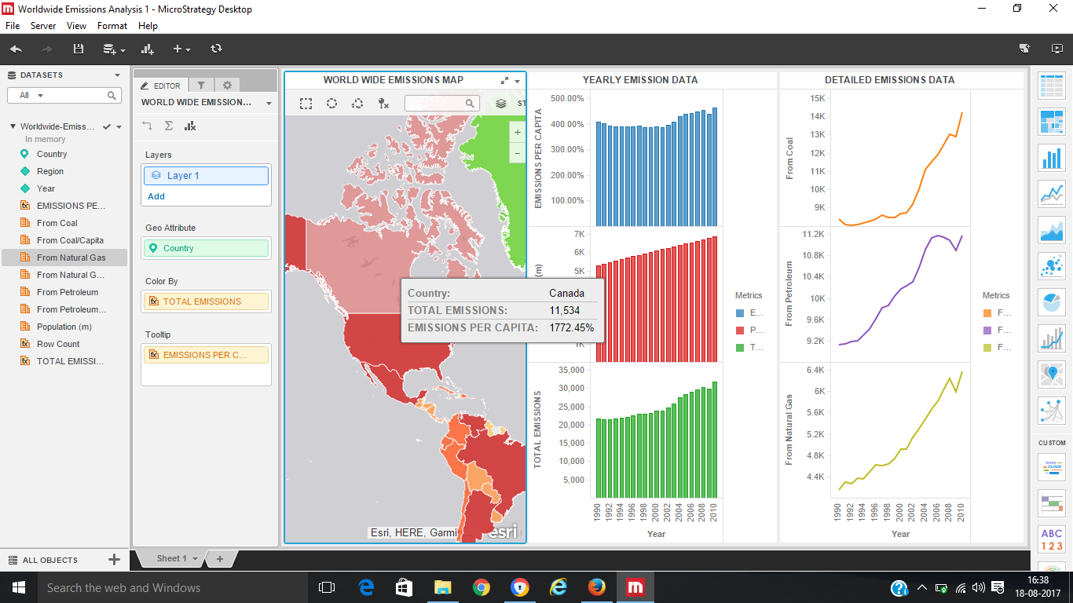

Q2: Overall trend as you can see in the world wide emissions visualization, many countries are red.

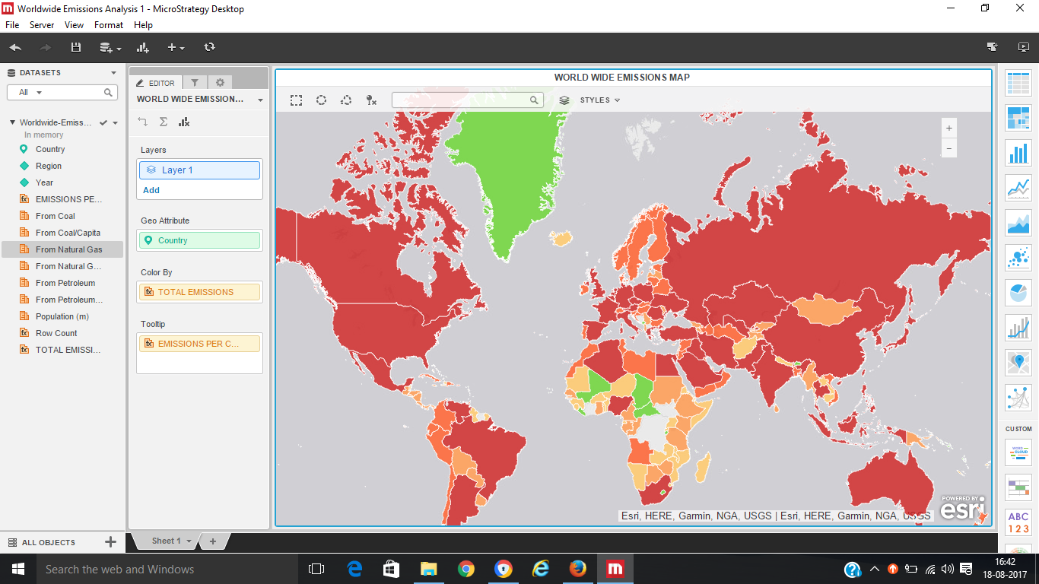

Q3: As, we observe the world wide emissions map, we can observe that, the 2 countries with the high emissions per capita are Canada and the United States. Their total emissions had a decline for the first time in years 1990 – 2010, in 2009. So, there is an overall decline in total emissions.

